
Partial Exam 1
Name ________________________________________________________________________
ID number __________________ Date _________________ Group ________
“Adhering to the Code of Ethics for students of the Tec de Monterrey, I pledge to follow the precepts of academic honesty in this evaluation by not using unauthorized or illicit resources to solve it.” _________________________________
Signature

I. Read the following questions and identify the option that best answers each, then write its letter on the line. (5 points each)

1. ______ Given the function fx=-2x2-4-5, which of the following represents its domain?
a) $(4,∞)$ b) $[4,∞)$ c) $(-∞, 4)∪(4,∞)$ d) $(-∞,∞)$
2. ______ A small publishing company is releasing a new book. The production costs is CN=10N+150 and each book is going to be sell at 2 dollars each $P(N)=2N$. Which of the following equations will represent $(C-P)(N)$?

a) C-PN=-10N+150+2N b) C-PN=2(5N+70-N)
c) C-PN=-2N+10N+150 d) C-PN=2N-10N-150

3. _____ Let $g\left(x\right)=\frac{4x}{x-1}$ and fx=x-5, then perform $g\left(7\right)$. Which of the following options represents the result?
a) $7$ b) $-7$ c) $4$ d) $\frac{14}{3}$

4. ______ The following piecewise function represents the cost of bathing a dog in the new grooming saloon. The cost depends on the weight of the dog, in kilograms. Which would be the cost for a dog that weighs 11.8 kg (11 kg and 800 grams)?
$$C\left(w\right)= \left\{\begin{aligned}150, w< 5 kg \\ 150+5w, 5≤w<12 \\ 175+50w, w≥12\end{aligned}\right.$$

a) $\$234$ b) $\$765$ c) $\$209$ d) $\$150$

II. Answer the following exercises.
- Determine the domain and range of the rational function depicted in the following graph.
(10 points)
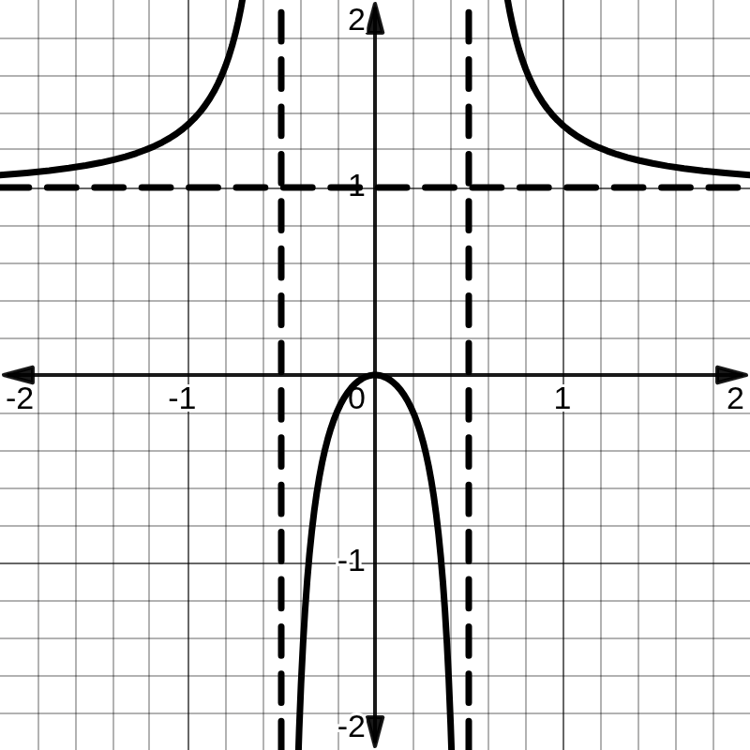 | Procedure
 | Answers

- Determine the vertical and horizontal asymptotes of the following equation. (10 points)
$$f(x)= \frac{2x-1}{x^{2}-x-2}$$
Procedure
Answer
- Determine the intersections with x and y. Write the final answers as coordinates. (10 points)
$$f\left(x\right)=\frac{x^{2}+x-6}{x^{2}-25}$$
Procedure
Answer

III. Solve the following exercises in an orderly and clear manner. Answers without procedure will not be considered. Underline or frame your final answer.

- Determine whether f and g are inverses of each other or not. Simplify your answer as much as possible. Justify your answer using $f\left(g\left(x\right)\right) and g\left(f\left(x\right)\right).$ (10 points)
$f\left(x\right)=\frac{x-1}{2}$ and $g\left(x\right)=2x+1$
Procedure
Answer

- Find $h^{-1}\left(x\right)$, given the following function $h\left(x\right)={\left(x+5\right)}^{2}$ for the domain $[-5,∞)$. (10 points)
Procedure
Answer

- Find the inverse function of $f\left(x\right)=\frac{5x-4}{x+3}$ (10 points)
Procedure
Answer

- Define the coordinate of the empty hole. (10 points)
$$f\left(x\right)=\frac{x^{2}}{0.5(x-2)3x}$$
Procedure
Answer

5. Graph the piecewise function. (10 points)

fx= x2, x∈[0,5]x-15330+1753, x∈[5,25]20x-24+2153, x∈[25,35]

